**REQUIREMENT SYSTEM**

***SEQUENCE DIAGRAM***

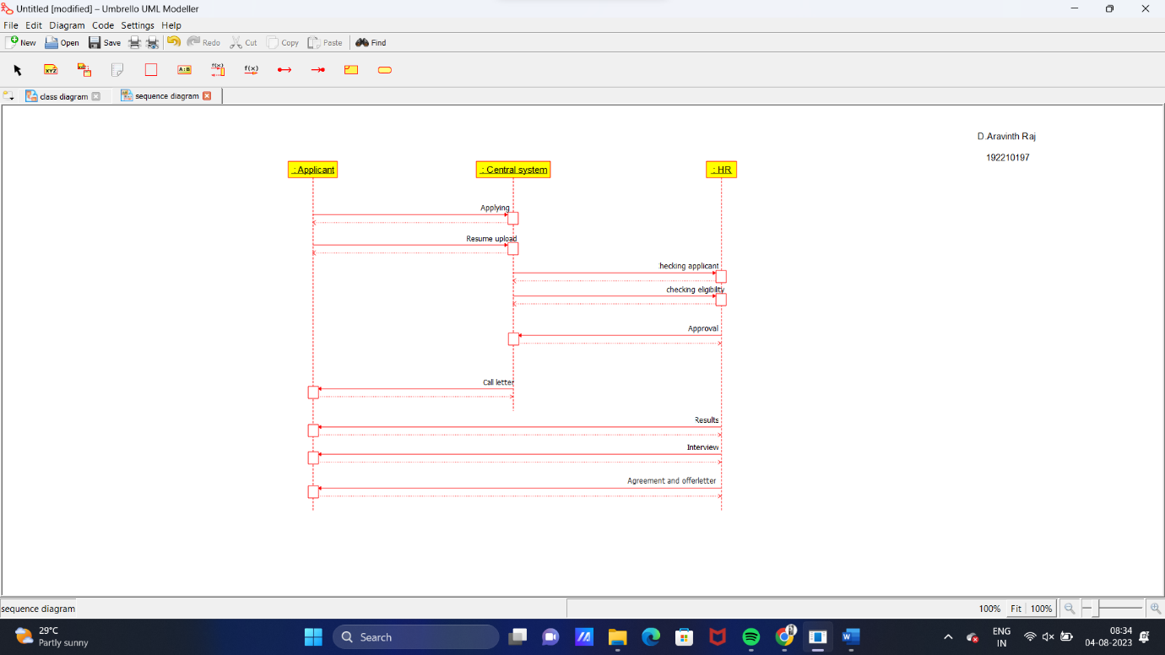

***DEPLOYMENT DIAGRAM***

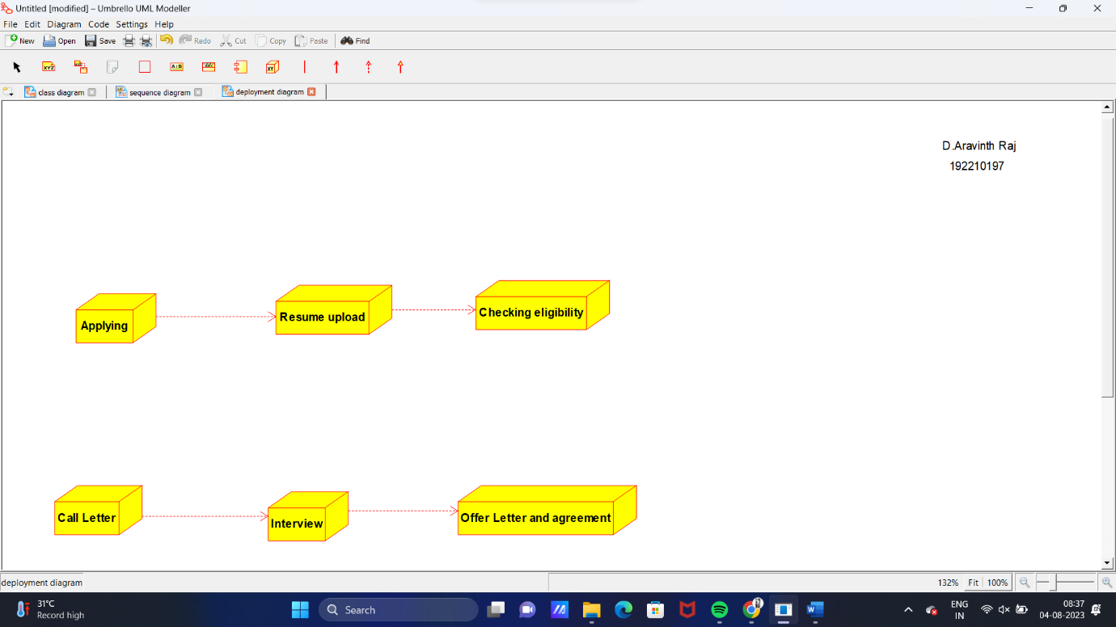

***STATE DIAGRAM***

